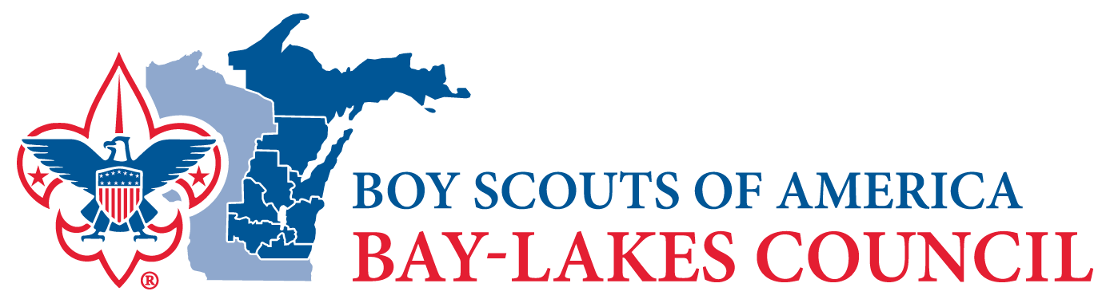

MEDIA ADVISORY
For more information, please contact:
Name
Unit #
Phone
Email
TITLE
Subtitle or additional information to explain title (optional)

Paragraph 1

Paragraph 2

Paragraph 3 (if necessary)

WHAT: what is the story about
WHEN: date, time
WHERE: location

List any visual opportunities for your story here

About Bay-Lakes Council
The mission of the Bay-Lakes Council, Boy Scouts of America is to instill in young people lifetime values and develop in them leadership skills and ethical character as expressed in the Scout Oath and Law.

Scouting's exciting programs are open to young men and women ages 5-20. To learn more about Scouting and to find a program site close to you, visit BeAScout.org

###

