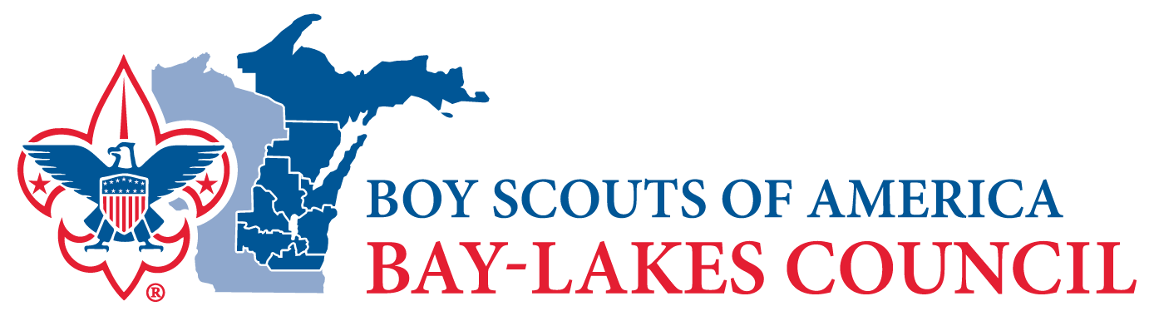

FOR IMMEDIATE RELEASE

For more information, please contact:
Name (replace “Name” with your name)
Unit # (replace “Unit #” with your unit type and number, example: Pack 123)
Phone (replace “Phone” with your phone number)
Email (replace “Email” with your email address)

TITLE
Subtitle or additional information to explain title (optional)

(YOUR TOWN) – Lead (Ideally, one sentence that grab’s the reader’s attention and summarizes the main idea of the story)

Write as many paragraphs as needed but keep to one-page total for the entire release.
Remember: write the most important information in the first few paragraphs, since editors will likely cut from the bottom up.

About Bay-Lakes Council
The mission of the Bay-Lakes Council, Boy Scouts of America is to instill in young people lifetime values and develop in them leadership skills and ethical character as expressed in the Scout Oath and Law.

Scouting's exciting programs are open to young men and women ages 5-20. To learn more about Scouting and to find a program site close to you, visit BeAScout.org

###

