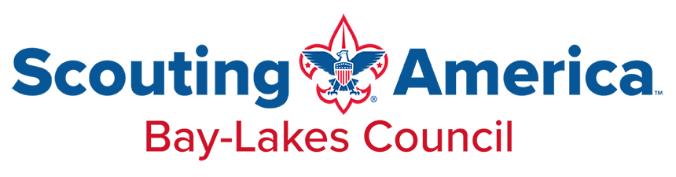

2025 Membership Assistance Application
Please note that requests may or may not be granted based on available funds and eligibility. Units are encouraged to provide assistance through fundraising efforts. All information is confidential. Complete one application per individual needing assistance.
To be Filled Out by the Parent/Guardian
Date:_______________________
Applicant’s (youth) full name: _________________________________________________________
Parent/Guardian Name: ______________________________________________________________
Address: ____________________________________________________________________________
City: _____________________________ State: ______ Zip: ___________________________
Phone: _____________________________________Email: __________________________________
Grade of Youth: ______________
# of Adult Family Members at Residence: _______ # of Children Family Members at Residence: _________
Annual Household Income: ______________________________________
Explain why assistance is requested. Provide detailed information on any special circumstances affecting the family’s income and expenses. Assistance will not be awarded without a detailed explanation: ________________________________________________________________________________________________________________________________________________________________________________________________________________________________________________________________________________________________________________________________________________________________________________________________________________________________________________________________________________________________________________________________________________________________________________________________________________________________________________________________________________________________________________________________________________
Parent/Guardian Signature: ________________________________________________________________

To Be Filled Out by the Unit Leader
Note to unit leader: Application will be rejected without every field filled out completely, and a paid, signed youth application is attached.
Unit # _____________________ District: _____________________________
Unit Leader Name: _____________________________________________________________________________
Unit Leader Email: ______________________________________ Phone: _______________________________
Is the Applicant a Returning Scout? Yes No Did the Applicant participate in Popcorn Sales? Yes No
Did the Applicant participate in any other unit fundraising? Yes No
If applicant is a returning scout, have they been actively involved in the unit? Yes No
Is the Unit contributing to the aid of applicant? Yes No If so, how much? $______________
How much was contributed by applicant (see chart): $____________________
Unit Leader Signature: __________________________________________________ Date: ________________

To Be Filled Out by Council
Date Received: ________________ Date Processed: ________________ Amount Awarded: ________________
Processed by: ____________________________________________________________________________________
Annual Adjusted Gross Income | Household Size
 | 2 | 3 | 4 | 5 | 6+
Below $21,000 | $ 42.00 | $ 12.00 | $ 12.00 | $ 12.00 | $ 12.00
$21,001-$30,000 | $ 42.00 | $ 42.00 | $ 38.00 | $ 12.00 | $ 12.00
$30,001-$40,000 | $ 63.00 | $ 55.00 | $ 52.00 | $ 42.00 | $ 42.00
$40,001-$50,000 | $ 89.00 | $ 80.00 | $ 72.00 | $ 63.00 | $ 50.00
$50,001-$60,000 | $ 97.00 | $ 97.00 | $ 97.00 | $ 89.00 | $ 80.00
$60,001-$70,000 | $ 97.00 | $ 97.00 | $ 97.00 | $ 97.00 | $ 80.00
The amount listed is the calculated rate for membership assistance for youth only, including the $12 Program Fee. This is the amount you will need to pay. The calculated rate is not guaranteed. Please submit the required assistance request form along with payment and a signed youth application form for verification.

